THE BALLYKINLAR BOOK
An Autograph Album from Ballykinlar Prison, 1921

Joe and Sheila, his new bride from Texas, are strolling in Dublin City in the mid-1930’s when a passerby tips his hat to Joe, who returns the gesture. “Who was that?” Sheila asks. “Oh, I was in jail with him,” he replies. The shock lessens for Sheila each new time it happens.
* * *

I am the keeper of my family’s stories.

I am the child who sat at Daddy’s feet and listened. In the most ancient of Irish customs - that of storytelling -- Daddy told me of the Irish struggle for independence, of the role he and his family played in the uprisings after 1916, of organizing London’s Irish dockworkers, of running guns to the rebels, of Scotland Yard raids on his home, and of imprisonment by the British. But I never heard about the Ballykinlar Book.

I am the teenager who hovered close to the coalite stove in the frigid post-World- War-II parlor of my elderly aunties’ London home, drinking tea or the occasional sherry. We chuckled at Aunt Cissy’s reminiscences of her hurling coach, Mick Collins, requiring the girls team to make uniforms out of certain materials. [I had no idea then who Michael Collins was.] She told stories of fugitives, and political reprisals, and raids by Scotland Yard on the family home in London. But she never said anything about the Ballykinlar Book.

In intervening years, my sister Kathleen speaks about an autograph book Daddy had in prison. She says she has seen it. Myths become embroidered over time. I once heard that some of the inscriptions were written in blood and urine!

I am the sixty-something woman following any family trail, and the trail leads me to Northampton, England. I meet Uncle Bill, eighty-six years old, and the last person alive who knew my grandparents and some of the Carr family members. “Your Dad was declared persona non grata by the British government,” he tells me. “He was made to leave the country.” Whether it is true or not, I do not know. But this is the sequence of events.

Joe Carr was London Irish. Together with his brother Dennis he was instrumental in procuring and running guns used by the Irish in the War of Independence. Their house off Hackney Road in East London was on Scotland Yard’s list of “usual suspects”.

In 1921 my father, John Joseph Carr, was imprisoned by the British in Ballykinlar Internment Camp in County Down . He was there for the better part of a year.

The signing of the Treaty in December 1921 precipitated conflict between the Republicans and the Free Staters. Using exactly the same arguments, Joe and his brother, Dennis, ended up on opposing sides of the Civil War. Joe would continue to be a passionate opponent of the Treaty, a thorn in the side of both the British and the new Irish Free State.

Sometime near the end of 1922 they met at Tommy Ryan’s bar in Dublin. “Give me your guns, boys,” the bartender said. Declaring that they loved each other too much to take up arms against the other, the brothers gave up the fight. Denny went back to London where he eventually opened a pub. Joe emigrated to America.

Joe’s British passport was issued on January 4, 1923, he sailed from England on the President Adams on January 27, and arrived in the United States on February 8, age 25. Did the Ballykinlar Book come with him then and pass through Ellis Island?

Joe Carr came to Texas where two of his sisters lived, and began selling ladies hats for a living. In time, he met the red-haired Texas beauty, Sheila Smith, and they fell in love. It was the deepest part of the Depression; work was not to be found. He returned to Dublin and opened the Licensed Trade Employment Agency on February 15, 1931. Sheila joined him in 1933, and they married

Joe and Sheila had three children by 1939 when the war broke out: Pat (1934) and Peggy (1937) both born in Dublin, and Mike (born in Dallas, Texas, 1939).

Germany invades Poland in 1939, and Europe is at war, but America not yet. In 1940, an American ship sweeps the European ports, picking up citizens and families. Ireland is the last stop.

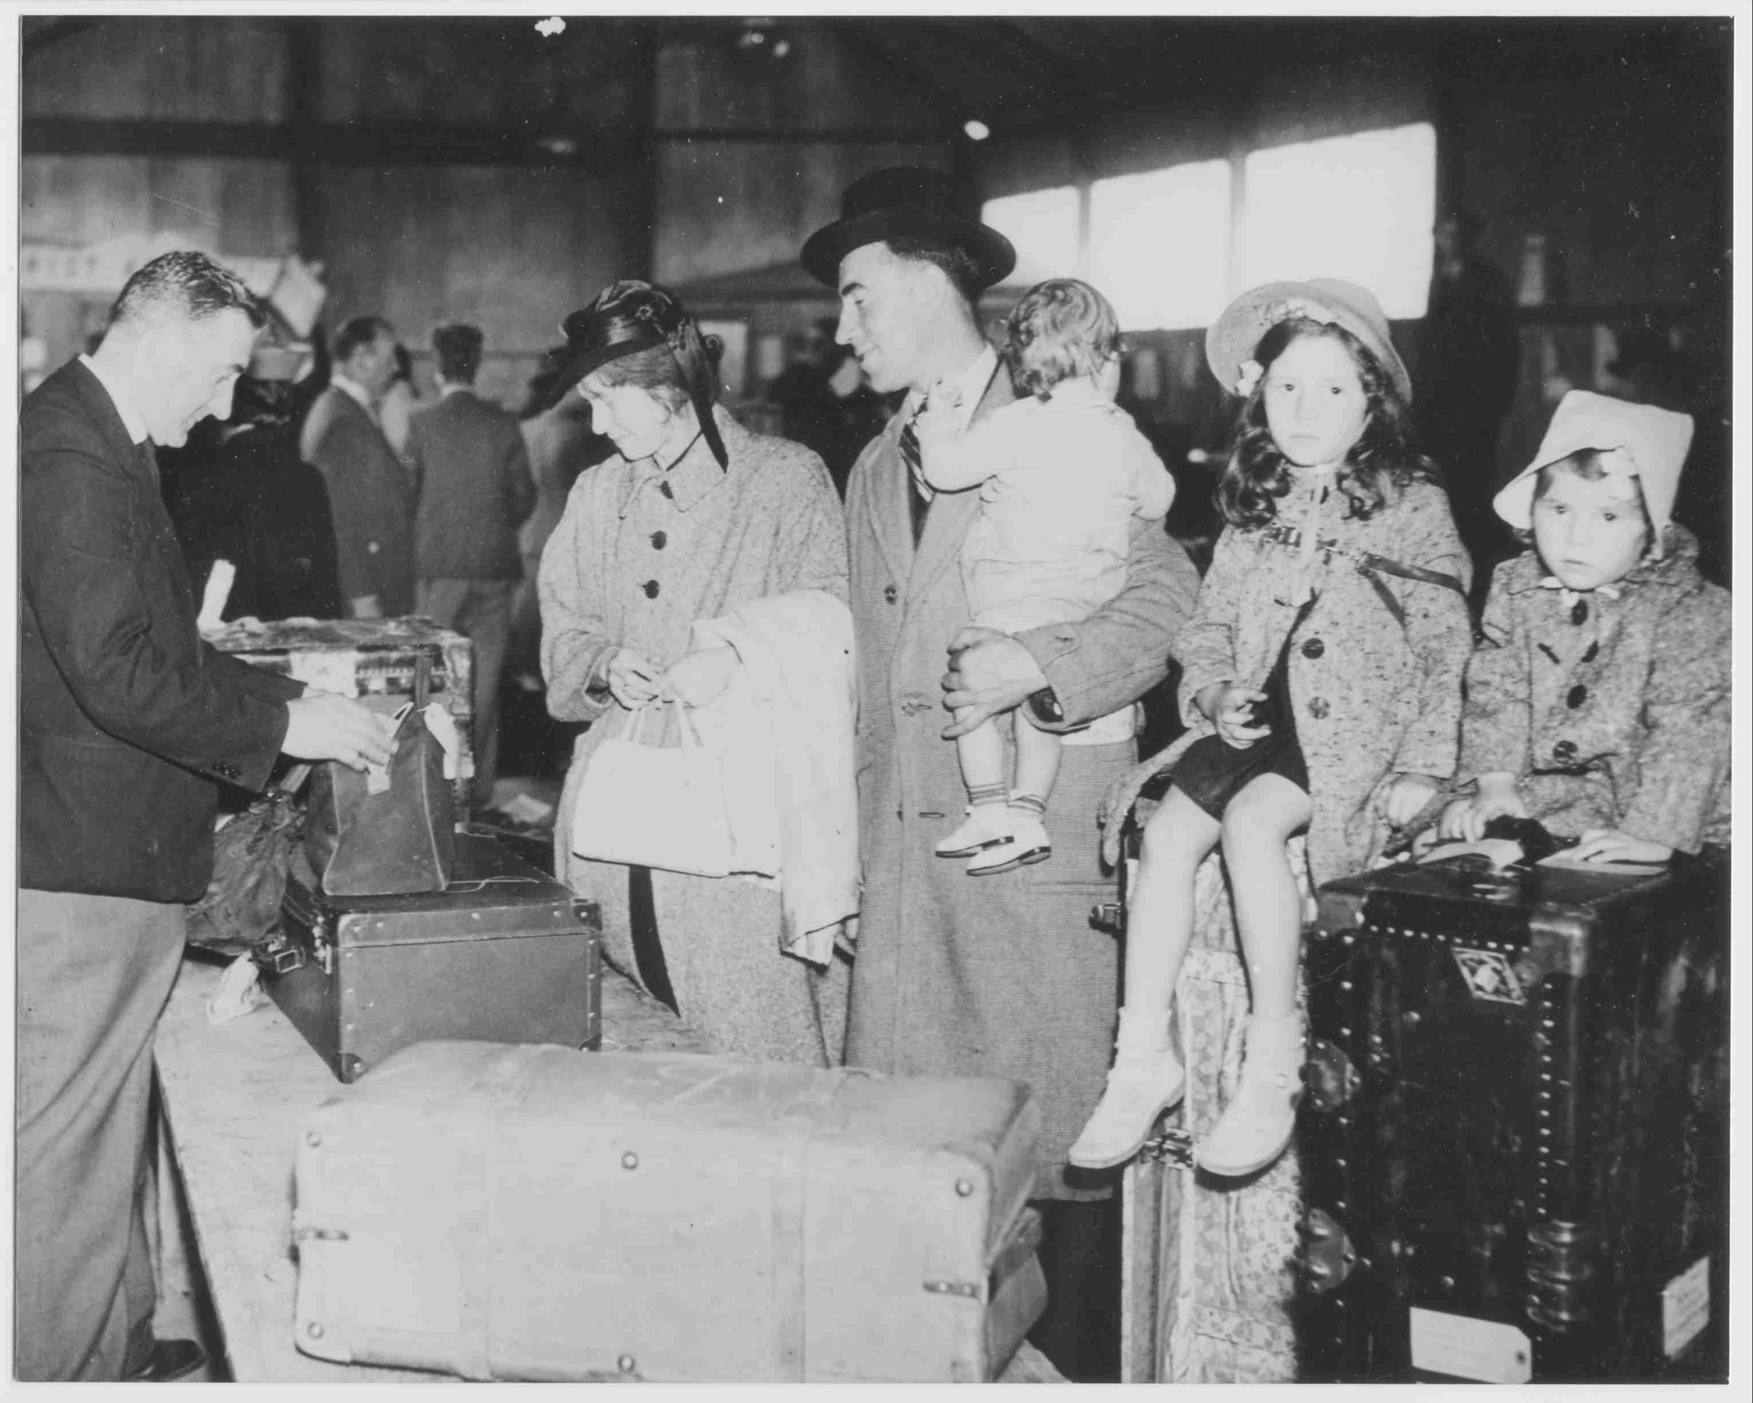
Sheila has just days to get tickets for her family of five, dispose of the household, pack what few things she can take. She arranges and signs for a loan for the passage. This is a picture of us at Galway port. I am the larger of the little girls sitting on the trunk. Thinking about it now,
I realize that among the few precious things in that trunk was the Ballykinlar Book.

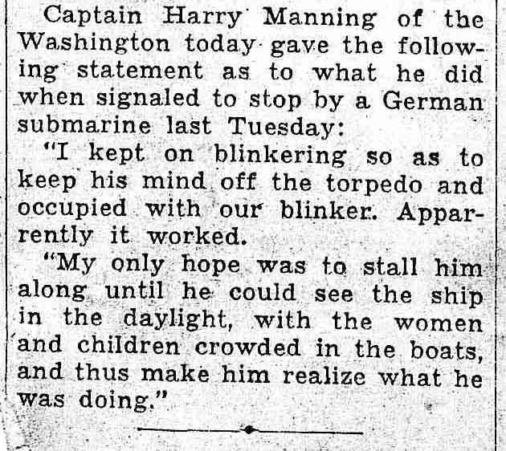
Sailing for America, the ship is stopped by a German submarine on the high seas. Newspaper accounts describe messages between the American and German captains. All children on board are made to climb into the lifeboats in the morning, so the sub’s captain can see we are non-combatants. The ship is allowed to proceed, we arrive in America, and the Ballykinlar Book has survived a potential torpedo.

In Dallas, our family increases by two more daughters. In an overstuffed household full of noisy children, Daddy often jokes: “Oh, for the peace of a nice quiet war!” The book is misplaced, at best, lost or tossed at worst.

Decades pass. Joe Carr died in 1973 in Dallas, Texas. Sheila Smith Carr died in 1992. My only brother, Michael Denis Carr, died in 1998. He never told me about the Ballykinlar Book.

In December of 2002, my sister-in-law Pat brought me a little box of Mike’s papers. She found them in an old garment bag in her attic. They had been there since God-knows-when.

And among those papers, I found the Ballykinlar Book.

It was instantly evident that this was an historic and genealogical gem. And, thankfully, it was not written in blood and urine.

It is a little autograph album, the size of a 4”x 6” photo. It cost eight shillings in 1909 - I know, because the sum is stamped in gold or silver on the corner of the cover. A tremendous sum in those days for a book of empty pages, it attests to a level of relative affluence of the original purchaser. (In contrast, my husband, a post-World-War-II refugee in England, earned 2£ 2s 0d in the late 1940s for 40 hours work in a textile mill.)

The book originally belonged to my Aunt Monica, Joe’s sister. Four pages are
autographed by young women, possibly her school chums, with romantic and feminine drawings, the earliest in 1908. Then it must have been put in a drawer and forgotten until 1921.

Aunt Cissy probably visited Joe in Ballykinlar Prison and brought him the book.
Over the period of half a year, he asked fellow prisoners to sign it. I am struck with the level of intelligence, wit and intensity evident in the prisoners’ remarks. They were literate, educated and dedicated men who knew exactly what they were fighting for. A number of inscriptions are in Gaelic, embodying the desire for national identity and separation

I am sad that Joe’s name and thoughts are not found on any of these pages. I like to think his mission was to witness and chronicle a chapter in Irish history whose story would one day be told.

To date, I haven’t uncovered my father’s arrest records at Scotland Yard. But
Joe did document his arrest and release dates from Ballykinlar in his IRA pension application:

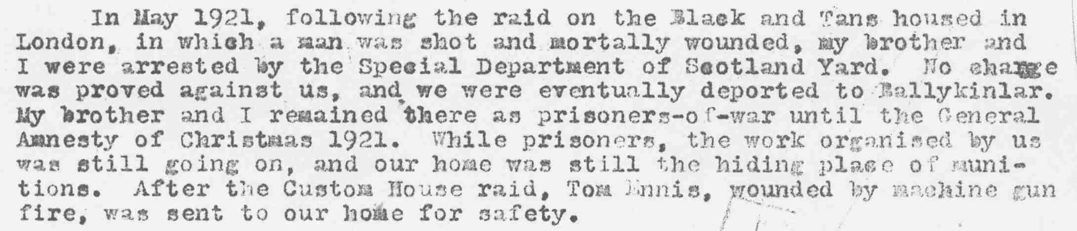

What a miracle that the Ballykinlar Book had survived into the New Millennium! More than eighty years had passed since those men had written their thoughts. The Book made at least one, possibly more, transatlantic journeys. It may have passed through Ellis Island. The Book was among the must-have possessions of a family fleeing war in Europe. It had survived a possible torpedo from a German submarine. The Book had suffered the ravages of Texas weather, where attics can regularly reach 150 degrees F. Incredibly, it had not spontaneously combusted, been chewed on by varmints, or been inadvertently thrown out with other papers.

In March 2003 I am taking the Ballykinlar Book to Dublin, where it will be donated to the National Library of Ireland. Simultaneously, the scanned and transcribed book, in data base format, will be loaded onto the Irish Genealogy Project’s RootsWeb site, where descendants of the 51 men who signed it can find them.

I‘m always so touched when one of my Irish relatives asks me “When are ye coming home?” As if I had never left.

By proxy, the Ballykinlar Book will be “coming home” in honor of Joe Carr and on behalf of the entire Carr family. There is only one place that it belongs - in the Republic of Ireland that these men fought for.

***

